**RESUME**

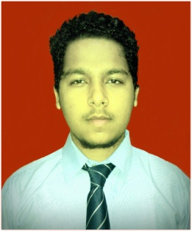

**NAME**: DHAN GOGOI

PRESENT ADDRESS: Post office: Govindpuri, New Delhi,

Pin code-110019

E-mail]: gogoidhan106@gmail.com

Mobile Number: 08448765229

____________________________________________________________________

**EDUCATIONAL QUALIFICATION:**

|  |  |  |  |  |
| --- | --- | --- | --- | --- |
| SL no. | QUALIFICATION | INSTITUTION | YEAR OF STUDY | PERCENTAGE % |
| 1 | UNDER GRADUATE | Dibrugarh university | pursuing | _ |
| 2 | AHSEC | Dibrugarh university | 2014 | 46.8% |
| 3 | Matriculation(SEBA) | Nilakhchopari high school | 2012 | 47% |

**WORK EXPERIENCE** (if any)**:**

* Fresher

**SOFTWARE KNOWLEDGE:**

* MS office (2003 , 2007)

**FIELD OF INTEREST :**

* (Maintenance / CAD/CAM / Tooling / Production / Quality Control /Marketing / Service )

**STRENGTH AND CAPABILITIES:**

* Hardworking in every situation whatever it is.
* Always with a Positive attitude & try to solve Problems.
* Take responsibility and ability to perform the work succesfully

**COMMUNICATION SKILLS:**

|  |  |  |  |
| --- | --- | --- | --- |
| Languages Known | Read | Write | Speak |
| English | Yes | Yes | Yes |
| Hindi | Yes | Yes | Yes |
| Assamese | Yes | Yes | Yes |

**EXTRA CURRICULAR ACTIVITIES:**

* Interested in Music & Drawing etc.

**PROFICIENCY IN SPORTS:**

* Cricket, Badminton etc.

**EXPECTED SALARY:**

* Negotiable

**PERSONAL DETAILS:**

1. Father’s Name : Mr.Ramesh Gogoi

2. Date of Birth & Age : 04-03-1995

3. Sex : Male.

4. Nationality : INDIAN

5. Marital Status : SINGLE

6. Permanent Address : Vill- Nilakh palengi P.O-palengi punch ali P.S- silapather

Dist- Dhemaji,Pin No-787110, ( Assam)

**DECLARATION :**

The above information given is true to the best of my knowledge and belief.

Date: 13.10.2017

Place: NEW DELHI

**Signature of applicant**